Pre-Test Name_________________________

- What is a standard unit for measuring battery capacity?
  - mAh
  - Wh
  - W
  - mA

- What is a standard unit for measuring battery energy?
  - mAh
  - Wh
  - W
  - mA

- What units are used when discussing safe charging or discharging practices for batteries?
  - mAh
  - Wh
  - W
  - mA

- The units of mAh is equivalent to what other unit?
  - Joules
  - Coulombs
  - Farads
  - Volts

- What is the working voltage range for a single lithium-ion cell?
  - 10.6V – 14.2V
  - 7.7V – 9.2V
  - 2.5V – 4.2V
  - 1.2V – 1.55V

- What is the advantage of connecting individual battery cells in series compared to a parallel combination?
  - The potential difference across the series combination is higher than the parallel combination
  - The total energy stored by the series combination is higher than the parallel combination
  - The series combination can handle a larger charge and discharge current compared to the parallel combination
  - None of the other choices are correct.

- What is the advantage of connecting individual battery cells in parallel compared to a series combination?
  - The potential difference across the parallel combination is higher than the series combination
  - The total energy stored by the parallel combination is higher than the series combination
  - The parallel combination can handle a larger charge and discharge current compared to the series combination
  - None of the other choices are correct.

- What schematic illustration shows how a non-ideal chemical battery can be modeled?
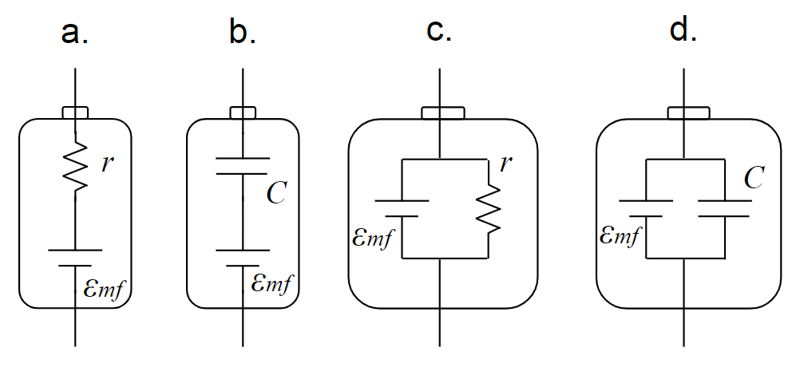

- A D-cell alkaline battery has potential difference of 1.6V across its terminals when it is not connected to a circuit. When the battery is connected to an external circuit the potential difference across the terminals is now 1.45V and there are 0.5 amps of current flowing through the battery. What is the resistance of the external circuit?
  - 3.2 Ω
  - 2.9 Ω
  - 0.8 Ω
  - 0.3 Ω

- A D-cell alkaline battery has potential difference of 1.6V across its terminals when it is not connected to a circuit. When the battery is connected to an external circuit the potential difference across the terminals is now 1.45V and there are 0.5 amps of current flowing through the battery. What is the internal resistance of the battery?
  - 3.2 Ω
  - 2.9 Ω
  - 0.8 Ω
  - 0.3 Ω

